Bad Education
By Alexandra Harney
January 24, 2013 7:28 am January 24, 2013 7:28 am
Photo
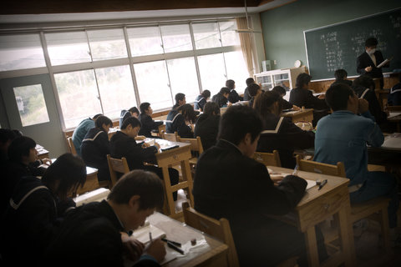
Credit Ko Sasaki for The New York Times
TOKYO — Japan’s educational system consistently makes the Organization for Economic Cooperation and Development’s top-20 list, and the Economist Intelligence Unit recently ranked Japan’s schools fourth after Finland, South Korea and Hong Kong.
You’d never know that, though, from talking to people here or reading the local press. Many Japanese are worried that their vaunted system, with its emphasis on cramming and getting into the right university, is failing to prepare Japanese students for the global economy.
Private spending on education in Japan is twice the O.E.C.D. average. Almost 30 percent of Japanese students attend private schools, according to the O.E.C.D. Many Japanese parents also enroll their children — sometimes at just 8 years old — in special cram schools, or juku, to help them prepare for exams they’ll take years later to enter private junior high school or public or private high school.
Juku offer extra classes after school and sometimes all day on Saturdays in math, science, English, Japanese and the social sciences. Teaching methods vary, but they inevitably involve lots of memorization and test-taking strategies.
At more than $3,000 a year, juku are not cheap, especially these days, after Japan’s long economic stagnation. But with only 15 percent of Japanese parents believing their children learn enough in regular school, according to one 2010 poll, juku endure. Almost one quarter of elementary school students and nearly half of junior high school students attend them.
But does the system make sense anymore? During Japan’s decades of rapid economic growth, when jobs for life were the norm, sending your son to juku to improve his chances of getting into a good high school and then a good university seemed like a good investment. But there are now more university places than applicants in Japan, which means that almost anyone who wants to attend can. And a university degree no longer guarantees students a job at graduation.
Worse, while the current system has made Japanese students “very good at answering problems for which answers exist,” says Mikio Takagi, the president of Nichinoken, one of the best-known juku, students are stumped by questions on which they haven’t been coached. And Japan’s sluggish economy needs people who can come up with new ideas.
Lin Kobayashi, founder of a new boarding school northwest of Tokyo that is slated to open in 2014, says typical Japanese schools don’t teach kids how to identify problems, take risks or “work alongside people with different values and backgrounds” — all increasingly important skills as Japan’s population declines and its companies are increasingly looking to expand abroad.
Starting in the 1980s, in response to concerns about the pressures on students of the university exam system, the government introduced a series of reforms collectively known as yutori education, or “pressure-free education,” to give students more time to rest and express themselves, and to reduce their course load. In the most recent round of yutori reforms that began in 1992, Japan scaled back the school week from six days to five.
But particularly after Japan’s rank in the O.E.C.D.’s 2003 education survey fell, critics argued that these reforms were lowering the quality of Japanese education. Prime Minister Shinzo Abe, who has long been an opponent of the yutori reforms, has declared that revitalizing the education system is a priority. The Ministry of Education, Culture, Sports, Science and Technology is mulling a return to a six-day school week and more work.
So Japanese kids will get to study even harder. But how much good will it do them or their country?
Alexandra Harney is an international affairs fellow at the Council on Foreign Relations based in Tokyo.
http://latitude.blogs.nytimes.com/2013/01/24/the-limits-of-japanese-education-and-its-focus-on-cramming/?_r=0

